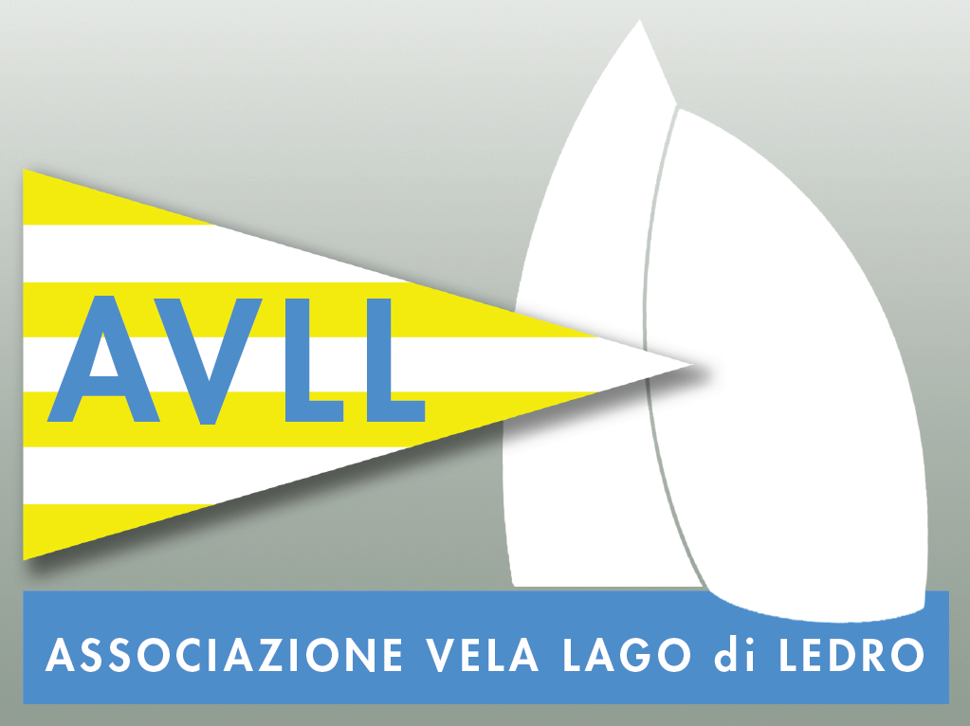 |  | 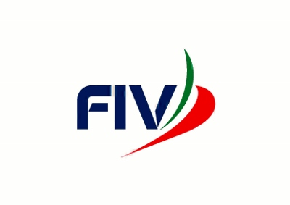 | 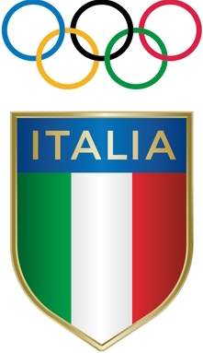
ASSOCIAZIONE VELA LAGO DI LEDRO A.S.D.
DUE GIORNI LEDRO - OPTIMIST A SQUADRE
Lago di Ledro - Trentino
7-8 MAGGIO 2016

SQUADRA A

NOME TESSERA FIV AICO DATA DI NASCITA

This declarations must be signed
I acknowledge that participation in this regatta is entirely at competitors' own risk and no
responsibility for damage, injury or loss from participating in this regatta will rest with the
Organising or National Authorities, Organising Committee, the Class Associations, the host
Club, or any person or agent of these bodies. I declare that I am either the parent or other
legal guardian of the above-named sailor or that I have been authorised by such a guardian
to sign this document on their behalf.

Place: Date: Signature:

I hereby authorize the OA handling and using my personal data as described in the
informative report printed on the back side of this form
.
Place: Date: Signature:

In participating in this event any competitor automatically grants to the Organising
Authority and the sponsors of the event the right in perpetuity, to make, use and show,
from time to time and at their discretion, any motion pictures and live, taped or film
television and other reproductions of him/her during the period of the competition for this
event in which the competitor participates and in all material related to the said event
without compensation.
Place: Date: Signature:

